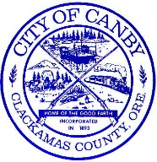
Phone: 503.266.4021
Fax: 503.266.7961
www.canbyoregon.gov
PO Box 930
222 NE 2nd Ave
Canby, OR 97013

City of Canby

City Council & Library Board Work Session Notice

April 25, 2018
6:00 PM
Mt. Hood Conference Room
222 NE 2nd Avenue
Canby, Oregon

This work session will be attended by the Mayor, City Council, and Library Board to discuss changes within the Library District.

For information regarding this work session, please contact the City Recorder at 503.266.0733. A copy of this notice can be found on the City’s web page at www.canbyoregon.gov.

