AGENDA
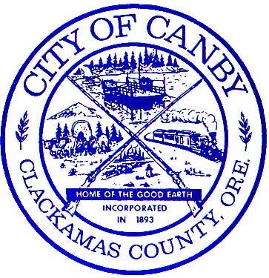
CANBY CITY COUNCIL MEETING
October 17, 2018
7:00 PM
Council Chambers
222 NE 2nd Avenue, 1st Floor

Mayor Brian Hodson
Council President Tim Dale Councilor Greg Parker
Councilor Tracie Heidt Councilor Tyler Smith
Councilor Traci Hensley Councilor Sarah Spoon
CITY COUNCIL MEETING – 7:00 PM

- CALL TO ORDER
  - Invocation
  - Pledge of Allegiance
  - Presentation by NW Natural Gas

- COMMUNICATIONS

- CITIZEN INPUT & COMMUNITY ANNOUNCEMENTS
(This is an opportunity for audience members to address the City Council on items not on the agenda. Each person will be given 3 minutes to speak. You are first required to fill out a testimony/comment card prior to speaking and hand it to the City Recorder. These forms are available by the sign-in podium. Staff and the City Council will make every effort to respond to questions raised during citizens input before tonight’s meeting ends or as quickly as possible thereafter. For Agenda items, please fill out a testimony/comment card and give to the City Recorder noting which item you wish to speak on.)

- MAYOR’S BUSINESS

- COUNCILOR COMMENTS & LIAISON REPORTS

- CONSENT AGENDA
(This section allows the City Council to consider routine items that require no discussion and can be approved in one comprehensive motion. An item may be discussed if it is pulled from the consent agenda to New Business.)
  - Approval of Minutes of the October 3, 2018 City Council Regular Meeting

PUBLIC HEARING
  - ANN 18-03/ZC 18-03 (ICON Construction) Pg. 1

RESOLUTIONS & ORDINANCES
  - Res. 1299, Reducing Street Tree Fees for New Development Pg. 63
  - Res. 1300, Authorizing the Extension of Municipal Sewer Service to 1751 N Redwood Street – Tax Lot Number 31E27C01502 – Located Outside of the Canby City Limits, Pursuant to the Urban Growth Management Agreement Between Clackamas County the City of Canby Pg. 65
  - Res. 1301, Requesting Clackamas County to Surrender Jurisdiction of S. Fir Street Between 13th Avenue (Mile Point 0.00) and the Current Canby City Limit (Mile Point 0.31), Being a Total of Approximately 1,609 Linear Feet Pg. 72
  - Res. 1302, Requesting Clackamas County to Surrender Jurisdiction of S. Fir Street Between the Current Canby City Limit (Mile Point 0.31) and End of S. Fir Street (Mile Point 0.37), Being a Total of Approximately 330 Linear Feet, 40 Feet in
Width Pg. 84
  - Ord. 1493, Proclaiming Annexation into the City of Canby of 9.55 Acres Including 8.91 Acres of Real Property and 0.64 Acres of Right-of-Way; Amending the Zoning; and Setting the Boundaries of the Property to be Included Within the City of Canby (2nd Reading) Pg. 94
  - Ord. 1496, Proclaiming Annexation into the City of Canby of 9.99 Acres Including 9.69 Acres of Real Property and Approximately 0.30 Acres of Adjacent N Pine Street Right of Way; Amending the Zoning; and Setting the Boundaries of the Property to be Included Within the City of Canby Pg. 51

NEW BUSINESS
  - Findings, Conclusions and Final Order ANN 18-02/ZC18-02 (Cutsforth) Pg. 100
  - Findings, Conclusions and Final Order ZC 18-04 (Busse) Pg. 102

- CITY ADMINISTRATOR’S BUSINESS & STAFF REPORTS

- CITIZEN INPUT

- ACTION REVIEW

- EXECUTIVE SESSION: ORS 192.660(2)(h) Litigation

- ADJOURN

*The meeting location is accessible to persons with disabilities. A request for an interpreter for the hearing impaired or for other accommodations for persons with disabilities should be made at least 48 hours before the meeting to Kim Scheafer at 503.266.0733. A copy of this Agenda can be found on the City’s web page at www.canbyoregon.gov. City Council and Planning Commission Meetings are broadcast live and can be viewed on CTV Channel 5. For a schedule of the playback times, please call 503.263.6287.

